Name: Aimee Steinwand
Group: Maddie, Kayla, Yemi

This group exercise contains a number of questions that pertain to the Multivariable Analysis R code (on github in PSA project repo). The goal of this exercise is to investigate what results from the crude analyses change when done in a multivariable framework. The group should work together and feel free to ask the instructors questions along the way.

A reminder of the description of the project and questions of interest:
PSA is a well-established screening test for prostate cancer. A university medical center urology group was interested in the association between prostate-specific antigen (PSA) and a number of prognostic clinical measurements in men with advanced prostate cancer. The data consist of 97 men who were about to undergo radical prostectomies. The questions of interest for this study are:

1) What factors are associated with PSA levels?
2) Do the associations depend on whether there is seminal vesicle invasion?

Each line of the data set has an identification number and provides information on 8 other variables for each person.
Column 1: Identification number
Column 2: PSA level (mg/ml)
Column 3: Cancer volume (cc)
Column 4: Weight (prostate weight in gm)
Column 5: Age of patient in years
Column 6: Benign prostatic hyperplasia (amount of hyperplasia in cm2)
Column 7: Seminal vesicle invasion (1 if yes, 0 if no)
Column 8: Capsular penetration (degree of penetration in cm)
Column 9: Gleason score—pathologically determine grade of disease using total score of two patterns with a higher score indicating worse prognosis

The following page is a Table of results from analyses with each covariate modeled separately (Crude Models) and one with them all in a model together (Full Model).

Table 1: Regression coefficients from models of potential predictors of Log PSA
Variable | Crude Models |  |  |  | Full Model***
 | Posterior Mean  (95% HPDI) | WAIC | LOO-CV | DIC | Posterior Mean  (95% HPDI) | WAIC with each variable removed | LOO-CV with each variable removed | DIC with each variable removed
Intercept only model |  | 304.1 | 304.1 | 303.8
Cancer Volume (CAVOL) | 0.096  (0.074,0.119) | 252.4 | 252.6 | 251.7 | 0.064  (0.033,0.095) | 247.9 | 248.3 | 246.7
Prostate Weight (WT) | 0.023  (0.011,0.034) | 290.7 | 290.7 | 290.6 | 0.01  (-0.001,0.020) | 234.8 | 235.4 | 233.3
Age | 0.027  (-0.005,0.058) | 303.8 | 303.9 | 303.0 | -0.006  (-0.029,0.018) | 230.5 | 231.0 | 229.8
Benign Hyperplasia (BPH) | 0.062  (-0.015,0.140) | 303.1 | 303.2 | 303.2 | 0.061  (-0.006,0.129) | 234.3 | 234.9 | 233.1
Capsular Penetration (CAPPEN) | 0.16  (0.104,0.21) | 276.0 | 276.1 | 275.9 | -0.025  (-0.091,0.04) | 231.0 | 231.4 | 230.2
Seminal Vesical Invasion (Yes/No;SVI) | 1.58  (1.04,2.06) | 268.8 | 268.8 | 268.8 | 0.78  (0.25,1.31) | 239.5 | 240.1 | 238.5
Gleason 7  (6 as reference) | 0.52  (0.067,0.97) | 271.9 | 272.0 | 271.7 | 0.30  (-0.070,0.68) | 235.9 | 236.4 | 234.9
Gleason 8  (6 as reference) | 1.76  (1.22,2.31) |  |  |  | 0.70  (0.162,1.22)
Full Model |  |  |  |  |  | 233.0 | 233.8 | 231.6
**Note for model fit statistics of the full model. For each variable you would compare to the full model and perhaps the other models to determine what is the best model to move forward with.

PART I
- Write a few key points from Table 1 summarizing the crude models.

Log(PSA) is associated with cancer volume, prostate weight, capsular penetration, seminal vesicle invasion and both Gleason indicators

Log(PSA) is not associated with age or benign hyperplasia

- Write a few key points from Table 1 summarizing the full model.

Gleason 7 and gleason 8 don’t add anything to the model since the WAIC increases by less than 3 points

After adjusting for other covariates, the only variables that are still significant (HPDI not including zero) are: cancer volume, seminal vesicle invasion, and Gleason 8

- Check the diagnostic plots for the MCMC output for the full model. Discuss the plots and the validity of the HMC sampler in STAN (5 minutes).

The above graphs are the ACF graphs of the trace plots for each of the 4 MCMC chains. The regression coefficients (betas) are: 1) Intercept, 2) cavol, 3) wt, 4) age, 5) bph, 6) svi, 7) cappen, 8) Gleason Grade 7, 9) Gleason Grade 8. The x-axis is 1 – 20, the distance between the iterations for the correlations shown.

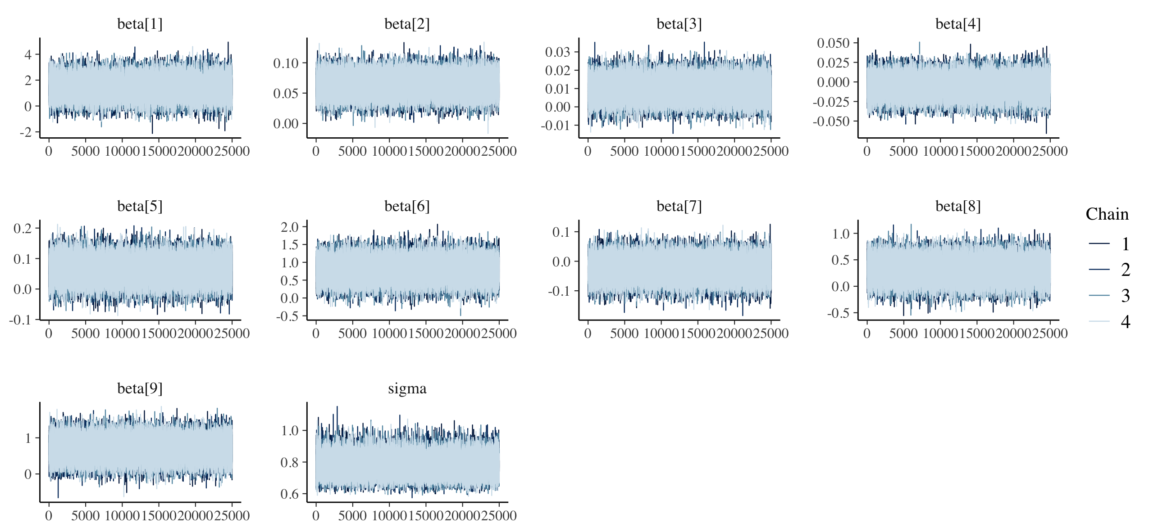
Trace plots across the 25,000 iterations for the 4 chains. The regression coefficients (betas) are: 1) Intercept, 2) cavol, 3) wt, 4) age, 5) bph, 6) svi, 7) cappen, 8) Gleason Grade 7, 9) Gleason Grade 8.

Posterior densities for the 4 chains. The regression coefficients (betas) are: 1) Intercept, 2) cavol, 3) wt, 4) age, 5) bph, 6) svi, 7) cappen, 8) Gleason Grade 7, 9) Gleason Grade 8.
These look great!
Part II
- The estimates for capsular penetration differ considerably between the crude and full models. Based on the DIC, WAIC and LOO-CV, do we need capsular penetration in the full model to improve model fit of PSA? What about in the crude model with only capsular penetration?

It doesn’t appear to be needed in the full model but does not appear necessary in the crude model.
- We will now investigate one potential cause of the change in estimates. Based on the correlation matrix (Table 2), briefly describe the relationships among capsular penetration, log PSA, and the other variables.
Table 2: Correlations between the outcome (PSA and Log PSA and potential predictors)
Pearson Correlation Coefficients, N = 96
Prob > |r| under H0: Rho=0
 | PSA | lpsa | cavol | wt | age | bph | cappen
PSA | 1.00000 | 0.72059  <.0001 | 0.62336  <.0001 | 0.15204  0.1392 | 0.01786  0.8629 | -0.01249  0.9039 | 0.54978  <.0001
lpsa | 0.72059  <.0001 | 1.00000 | 0.65637  <.0001 | 0.38274  0.0001 | 0.17073  0.0963 | 0.16249  0.1137 | 0.51689  <.0001
cavol | 0.62336  <.0001 | 0.65637  <.0001 | 1.00000 | 0.17719  0.0842 | 0.04039  0.6960 | -0.12668  0.2187 | 0.69155  <.0001
wt | 0.15204  0.1392 | 0.38274  0.0001 | 0.17719  0.0842 | 1.00000 | 0.35975  0.0003 | 0.55733  <.0001 | 0.13661  0.1844
age | 0.01786  0.8629 | 0.17073  0.0963 | 0.04039  0.6960 | 0.35975  0.0003 | 1.00000 | 0.36665  0.0002 | 0.10071  0.3289
bph | -0.01249  0.9039 | 0.16249  0.1137 | -0.12668  0.2187 | 0.55733  <.0001 | 0.36665  0.0002 | 1.00000 | -0.07748  0.4531
cappen | 0.54978  <.0001 | 0.51689  <.0001 | 0.69155  <.0001 | 0.13661  0.1844 | 0.10071  0.3289 | -0.07748  0.4531 | 1.00000

- One of the variables is acting as a potential confounder or collinear variable with capsular penetration. Which variable is this?

- Draw potential diagrams of what is conceptually occurring between these three variables.

PART III
- Models 2-4 below examine the relationship between Log PSA and capsular penetration and cancer volume. Compare the parameter estimates and standard deviations for the associations between capsular penetration, cancer volume and Log PSA from model 4 to those in models 2 and 3. Describe what changes you see across the different models.

Model 2: Cavol and Cappen in the model
Parameter | Estimate | MCSE | Std. Dev. | 95% HPDI
(Intercept) | 1.81 | 0.001 | 0.123 | (1.56, 2.05)
cavol | 0.084 | 0.0001 | 0.016 | (0.053, 0.116)
cappen | 0.037 | 0.0001 | 0.033 | (-0.027, 0.104)
sigma | 0.788 | 0.0003 | 0.067 | (0.762, 1.02)

Model 3: Cavol only model
Parameter | Estimate | MCSE | Std. Dev. | 95% HPDI
(Intercept) | 1.80 | 0.001 | 0.122 | (1.56, 2.04)
cavol | 0.096 | 0.0001 | 0.012 | (0.074, 0.119)
sigma | 0.891 | 0.0002 | 0.066 | (0.766, 1.02)

Model 4: Cappen only model
Parameter | Estimate | MCSE | Std. Dev. | 95% HPDI
(Intercept) | 2.13 | 0.001 | 0.120 | (1.89, 2.36)
cappen | 0.158 | 0.0001 | 0.027 | (0.104, 0.211)
sigma | 1.01 | 0.0002 | 0.075 | (0.868, 1.16)

- Write a summary of your findings regarding capsular penetration and its value as a predictor of PSA both alone and in the presence of the other covariates.

